CHANDIGARH

UNIVERSITY

BEE LAB COURSE

SUBMITTED BY :

SAKSHI TANWAR

UID : 19BCS4009

COURSE : B.E CSE(H)CLOUD COMPUTING

GROUP : A

SUBJECT CODE : ELP118

SUBMITTED TO :

MR. ANSHUL SHARMA

PROJECT : DESIGN A LED FLASHER

AIM :

DESIGN A LED FLASHER .

APPARATUS :

Arduino board , LED , Resistance – 220 ohm , Breadboard , Digital Multimeter .

THEORY:

LED is Light Emiting Diode . LED’s are like tiny lightbulb . Designing a LED flasher is a very simple task . The blinking LED circuit is like the electronics version of the “HELLO WORLD” – program . It’s a simple electronic circuit that gives you a visual cue if it works .

There are many possible applications for the circuit below especially for kids , who love flashing lights . Here’s some possible uses.

1. Railroads crossing signal for model railroads.
2. Safety blinkers for bicycles , etc.
3. Fun stuff for Halloween , like making those plastic jack-o-lanterns blink (using UV LED’s).
4. Christmas decorations .
5. Blinkers to locate items in the dark.
6. Toys and etc.

CONCEPT USED:

LED flashers are semiconductor integrated circuits used to turn on and off groups of light emitting diodes either sequentially or according to a program pattern. They are found in circuits used as indicators and controllers, as well as in home – built projects.

LED flashers are typically bought in the form of a complete module that has prongs for plugging into an outlet and extenders for connecting to the circuit . some LED flashers can also come as an integrated circuit (IC) unit or chip which require a power source in addition to the connection to the circuit.

FEATURES :

LED flashers can exhibit a number of features which may be important to certain applications.

1. Reverse polarity protection – the flasher has circuitry that protects it from a reverse polarity at the input . reverse polarity occurs when positive and negative terminals are reversed due to incorrect wiring or connections.
2. Silent operation – the flasher doesn’t make the clicking sound and noises associated with normal operations.
3. Surge protection – the flasher has a surge protector devices at its input to prevent electrical surges from destroying the device .
4. Waterproof – the flasher design provides protection from water or liquid contact.

CIRCUIT DIAGRAM:

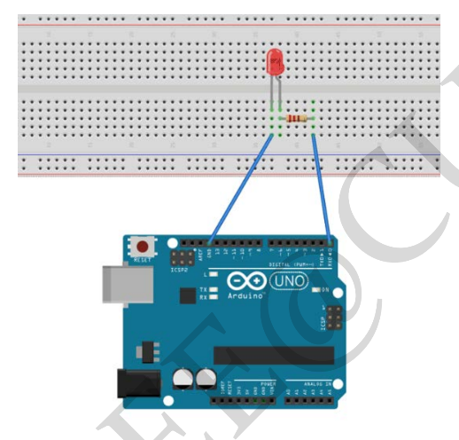

FLOWCHART :

// the setup function runs when u introduce pin mode// void setup () {

// initialize digital pin LED BUILTIN as an output . and introduce pin mode

digitalwrite(13,high);//turn the LED on (high is the voltage level)

delay(1000);//wait for a second //

//digitalwrite(13,low);// delay (1000);//wait for a second//

SETUP

TURN ON LED

DELAY(1000ms)

Turn off LED

Delay(1000ms)

CODE:

int led_flasher=13; //defines usage of pin 13 for connecting LED//

void setup ()

{

pinMode (13, OUTPUT) ;

// initialize digital pin led_flash as an output .

}

//the loop function runs over and over again forever//

Void loop ()

{

digitalwrite(13, high); //turn the LED on (high is the voltage level )//

delay(1000); //wait for a second //

digitalwrite(13,low); //turn the LED off by making the voltage low//

delay(1000); //wait for a second//

PROCEDURE :

1. Take all the components .
2. Arrange them on breadboard as shown in circuit diagram .
3. Do the coading of arduino.
4. Connect arduino to hardware.
5. Coad will be uploaded on breadboard.

Precautions :

1. All the connections must be tight.
2. Pin should be correct in software as well as in hardware.
3. Check if any connection may get short circuited .

Learning outcomes :

1. ARDUINO and its application.
2. LED and its application in daily life.
3. LED Flasher and it application in daily life